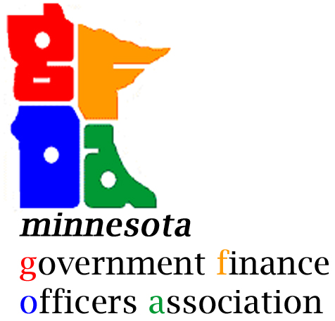 MNGFOA Day to Unite
Wednesday, August 19, 2026
11:30am – 2:00pm

- Networking Lunch

- Introductions
  - Name, Title, Entity
  - What challenges or opportunities is your entity experiencing?

- Discussion (potential topics)
  - Audit Recap

  - Budget
    - Preliminary estimates (levy increase, COLA, utility rates)
    - Fire model/staffing
    - Health insurance premiums
    - Compensation study/union contracts

  - New Initiatives or Projects
    - Creative/new funding solutions
    - Capital planning
    - Financial software
    - Outsourced services

  - Legislative Impacts
    - Paid family and medical leave
    - Local affordable housing aid/local housing trust fund (metro area)
    - State affordable housing aid/local housing trust fund (greater MN)
    - OBBBA
    - OSA TIF Reporting Form
    - Health and Human Services Act (country programs impacted)

  - AI

  - Election Administration

  - Economic/Market Outlook
    - Interest rate impact on debt and investments

  - Attendee Submitted Topics

